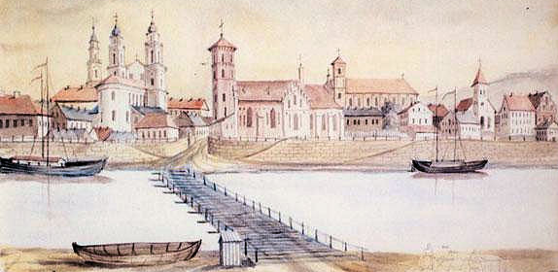
Napoleon Orda: Old city from Aleksotas Hill ( 1875)

LITHUANIAN UNIVERSITY OF HEALTH SCIENCES MEDICAL ACADEMY INSTITUTE OF ONCOLOGY
HOSPITAL OF LITHUANIAN UNIVERSITY OF HEALTH SCIENCES KAUNO KLINIKOS
KAUNAS REGION SOCIETY OF ONCOLOGISTS, HEMATOLOGISTS AND TRANSFUSIOLOGISTS
LITHUANIAN ASSOCIATION OF APHERESIS AND CLINICAL TOXICOLOGY

2nd Kaunas International Hematology/Oncology Colloquium
“New treatment modalities: molecular and cellular therapies”
22 May 2017
Kaunas
Preliminary Scientific Programme
8.00–8.30 Registration | Sponsors exhibition
8.30–8.50 Welcome speech and opening of the conference
Prof. Remigijus Zaliunas, Rector of the Lithuanian University of Health Sciences
Prof. Renaldas Jurkevicius, Director General of Hospital of Lithuanian University of Health Sciences Kauno klinikos
Prof. Aurelijus Veryga, Minister of Health of Lithuania
Session I
Chairs: Prof. Daiva Rastenyte, Prof. Dietger Niederwieser
8.50–9.20 JACIE regulation in Europe and worldwide
Eoin McGrath (Barcelona, Spain)
9.20–9.50 New therapy options/possibilities from a patient´s perspective
Anita Waldmann (Bonn, Germany)
9.50–10.30 The first successful cellular therapy: allogeneic stem cell transplantation
Prof. Dietger Niederwieser (Leipzig, Germany)
10.30–11.10 Coffee break | Press conference | Sponsors exhibition
Session II
Chairs: Prof. Vaiva Lesauskaite, Assoc. prof. Rolandas Gerbutavicius
11.10–11.30 How digital tools can improve patient care
Domas Vaitiekus (Kaunas, Lithuania)

11.30–12.10 Multiple Myeloma: a complex disease
Prof. Wieslaw Wiktor Jedrzejczak (Warsaw, Poland)
12.10–12.30 Autologous hematopoietic cell transplantation for myeloma
Dr. Milda Rudzianskiene (Kaunas, Lithuania)
12.30–13.10 Autologous stem cell transplantation in lymphoma
Prof. Peter Dreger (Heidelberg, Germany)
13.10–14.10 Lunch break | Sponsors exhibition
Session III
Chairs: Prof. Elona Juozaityte, Prof. Sonata Jarmalaite
14.10–14.50 Chimeric Antigen receptor T cells in the treatment of oncological diseases
Prof. Peter Lang (Tubingen, Germany)
14.50–15.40 Applying Genome Editing Technologies for Target Identification, Validation and novel Treatment Combinations
Prof. Roderick L. Beijersbergen (Amsterdam, Netherlands)
15.40–16.20 Cellular therapy for the treatment of neurological diseases
Prof. Frank Edenhofer (Innsbruck, Austria)
16.20–16.40 Coffee break | Sponsors exhibition
Session IV
Chairs: Prof. Inga Bumblyte, Dr. Vladan Vucinic
16.40–17.10 Acute lymphocytic leukemia treatment protocols
Dr. Vladan Vucinic (Leipzig, Germany)
17.10–17.30 Can we induce treatment free remissions with molecular therapy in chronic myelogenous leukemia?
Assoc. prof. Rolandas Gerbutavicius (Kaunas, Lithuania)
17.30–17.50 Cellular therapy for immune modulation
Egle Simaskiene (Kaunas, Lithuania)
17.50–18.00 Concluding remarks
Prof. Dietger Niederwieser (Leipzig, Germany)

